**Chang Gung Pneumothorax (CGPNX) Database**

**Introduction**

CGPNX database is one thematic database which contains 1,563 patients who were diagnosed with Pneumothorax based on Chest X-ray radiographs at Chang Gung memorial hospitals, Taiwan. The image data in this database was de-identified for privacy protection and accompanying with each patient’s demographic data. Though deidentified, CGPNX database contains detailed clinical information and requires credentialing before access.

**Patient Cohort**

Pneumothorax cases collected in six branches of Chang Gung Memorial Hospital between 2015 and 2019 will be reviewed. Pneumothorax diagnosis was determined mainly by chest X-ray report from radiologists adjuvant with other clinical evidence. Through the clinical procedure, patients with chest pain usually took their first X-ray image. If he/she was confirmed to be pneumothorax cases, further chest tube placing was carried out. Here, we specifically selected the first image before any tube was placed. Images with chest tub were all excluded from this database. Finally, there were 1,567 pneumothorax patients included in this database.

From 2015 to 2019, data collected from CGMH

(patients, N = 16,306)

Without pneumothorax and no tub

(patients, N =13,798)

(patients, N =3384)

With Chest Tub

(patients, N =1817)

Total (patients, N = 1567)

**Data Description**

CGPNX database is a relational database consisting of EHR, radiology images, and radiograph reports. EHR data were all recorded by medical encounter.

**Patients’ demographic data Summary Table**

|  |  |  |  |
| --- | --- | --- | --- |
| Female | Male | Avg_age | Std |
| 223 (12.77%) | 1523(87.22%) | 37.3860 | 20.56266 |

**Variables Characteristic**

The CGPNX database contains a variety of clinical information which could be useful for researchers to conduct multidisciplinary researches. Some important features included:

* Diagnosis code (reported by Radiologist annotation)
* Demographics (such as Idcode, age, Sex, Study date...)
* Imaging parameters (KVP, Windows level, windows width.)

Example image from patients with or without pneumothorax

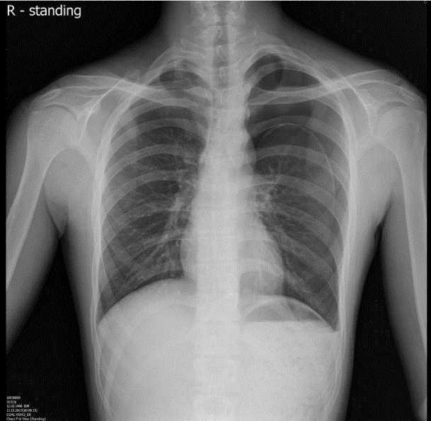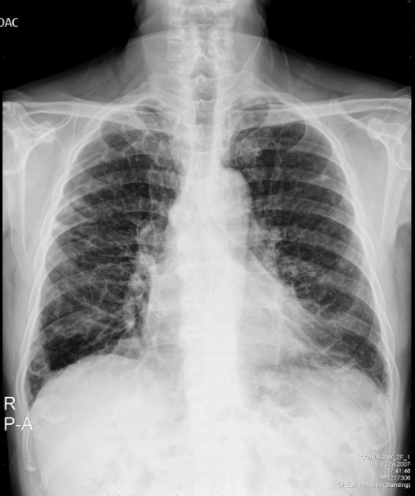

**(pneumothorax) (No pneumothorax)**

**Requesting Datasets**

To request a dataset, please contact the Center of Artificial Intelligence in Medicine at [cgmhailab@gmail.com](mailto:cgmhailab@gmail.com)

![Image](https://github.com/cgmhai00/Database/blob/master/original.jpg)